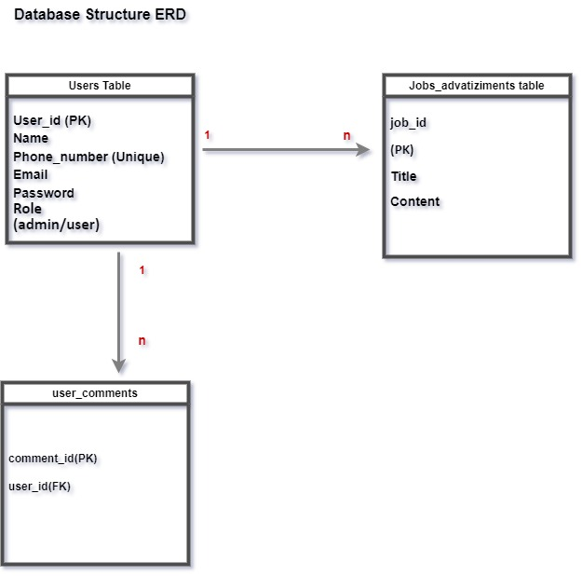

Users Table
Column Name | Type | Description
user_id (PK) | INT | Unique user identifier
name | VARCHAR | User's full name
phone_number | VARCHAR (Unique) | Contact number
email | VARCHAR | User's email
password | VARCHAR | Hashed password
role | ENUM(admin/user) | User role
created_at | TIMESTAMP | Account creation date

Job_Advertisements Table
Column Name | Type | Description
job_id (PK) | INT | Unique job identifier
user_id (FK) | INT | Posted by user (References Users)
title | VARCHAR | Job title
content | TEXT | Job description
status | ENUM(Active/Expired) | Job availability
created_at | TIMESTAMP | Job posting date

User_Comments Table
Column Name | Type | Description
comment_id (PK) | INT | Unique comment identifier
user_id (FK) | INT | Commented by (References Users)
job_id (FK) | INT | Related job post (References Job_Advertisements)
review | TEXT | User feedback or comment
rating | INT(1-5) | Optional rating feature
created_at | TIMESTAMP | Comment date

Updated Relationships:
- Users (1) → (M) Job_Advertisements (user_id FK in Job_Advertisements)
- Job_Advertisements (1) → (M) User_Comments (job_id FK in User_Comments)
- Users (1) → (M) User_Comments (user_id FK in User_Comments)

